**Ha Long Tour - Tuan Chau Island 3 Days 2 Nights**

*Attention:*

-Departure point: Hanoi.

-Time: 3 days 2 nights.

-Media: car

-Price: 1935000đ

-Image:

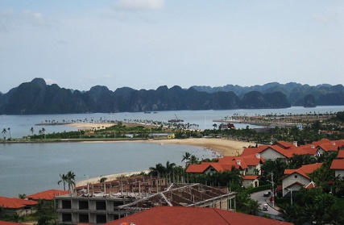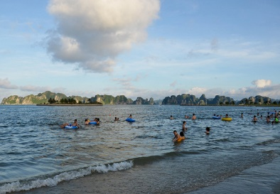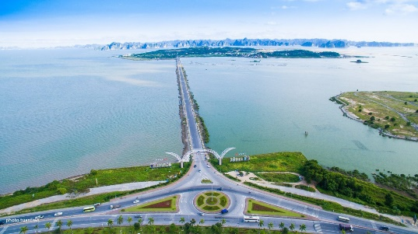

**I.Introduce:**

Looking down from above, Ha Long Bay looks like a giant picture of extremely vivid water with thousands of rocky islands. In some places, gather, gather together, there are separate places to separate, creating extremely skillful strokes. Under ingenious hands, the talent of creation, the inanimate, quiet rocky islands become vivid, familiar characters with humans. The island is like a pair of chickens together playing around on the water waves (Drum Roof), reversing like a giant tortoise resting sleep (Turtle island) or like an old monk clasping his hands towards the sea chanting for recitation Buddha (Ong Su island).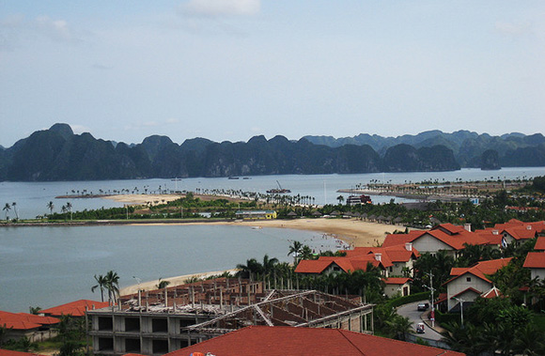

Tuan Chau Island Resort is about 2km from the center of Ha Long City. Tuan Chau Island tourist area has an area of ​​220ha, created by gentle hills. A paved road about 2 km long connects the island to the mainland. In Tuan Chau, there are many construction items that have been built. From outside the gate, in turn, visitors will come across a hill with a villa area with international standard infrastructure. Continue into the culinary district with five restaurants and round houses designed with very beautiful royal architecture at the same time that can serve over 1,000 diners with European, Asian and ethnic dishes prepared by chefs. Famous at home and abroad made. The flight attendants are all dressed in traditional Vietnamese attire. Visitors to the center will be overwhelmed by the dolphin, seal, lion-lion performance club built very modern and unique.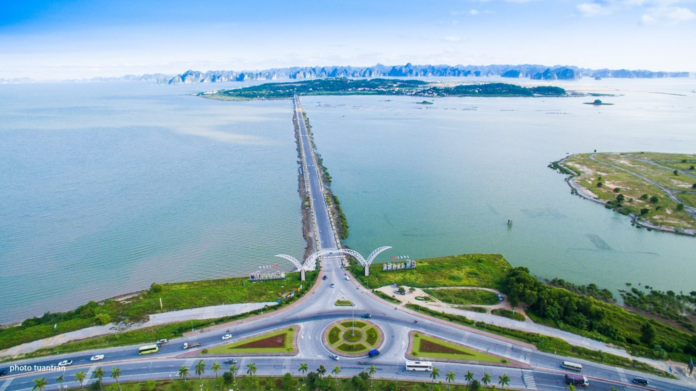

**II.** **Tour schedule:**

**1.Day 1:**

**HA NOI - HA LONG**

_____________________________________________________________________

06h00: Car and guide of Viet Center pick you up at the meeting point of departure to Ha Long. On the way, rest and have breakfast (own expense) at Sao Do - Hai Duong. To Ha Long, you check in hotel, lunch and rest in the city.

Afternoon: You are free to visit Ha Long city and swim Bai Chay - one of the impressive beaches of Ha Long city.

Evening: After dinner, take the car to visit Tuan Chau Island - the largest and most modern amusement park in Ha Long. See the shows Dolphin, Water Park .. (Self-sufficient expenses).

_____________________________________________________________________

**2.Day 2:**

**EXPLORE THE HA LONG BAY**

_____________________________________________________________________

In the morning: After breakfast, the coach and tour guide will take you to the cruise ship port, board the train to visit Ha Long Bay - recognized by UNESCO as a world natural heritage, watching Ga Choi Stone, Hon Cho Da, Peak Lu Huong, Bai Tho Mountain, visit Sung Sot Cave and Titop Island .. Return to the hotel for lunch. Afternoon: You are free to visit the beach. 19h00: Participating in the GALADINER PROGRAM - The administrator and the cheerleaders will lead the participants in collective games, fun and light-hearted games that still require teamwork. , the values ​​of the collective, of the internal solidarity: Planting bananas with thighs, counting frogs, fruit-eating competitions, disco dance, butt-ball stamping, treasure-hunting ships ... These games are designed to break the initial fears among the members, create a fun, friendly atmosphere so that everyone is ready for the next show. (MC will integrate the entertainment program + games for rich and attractive). All together, participating in the exciting indoor game program with fun games, creating a happy, warm and intimate atmosphere between the Board of Directors and the entire staff, is also an opportunity for the employees. employees understand more about the Group and its corporate culture. Games can be built on the current famous Game shows like "Vietnam Idol", "Perfect Couple", "Overcoming challenges" to provide more knowledge about the company, the product as well. as an opportunity for employees to show their talents and help the whole team to have unforgettable moments. _____________________________________________________________________

**3.Day 3:**

**HA LONG - TUAN CHAU ISLAND**

_____________________________________________________________________

Morning: After breakfast, you are free to swim. 12h00: Check out procedures and board the bus to Hanoi. On the way back, stop at Sao Do town to rest and buy Hai Duong mung bean cake specialties as gifts for relatives and families. 18h30: Arrive in Hanoi, end the program, guide Viet Center farewell and see you again! _____________________________________________________________________

**III.** **INCLUDED AND TERMS:**

**Service includes:** • Newer cars travel on tour• Guides experience, enthusiasm during the tour• Standard hotel 3 * (sleeping 02 guests / room)• Tickets to the sights of the program• Eat 5 main meals 120,000 VND / person• Gifts: Drinking water, cold towels, .. **The service does not include:** • VAT, • Tips for guide, driver, service staff, ...• Kayaking / bamboo boat activities on the Bay• Cable car tickets, tickets to Tuan Chau entertainment area, ..• Telephone, laundry, drinks, single room sleep, personal expenses **Please note:** • Children 1-4 years old free (parents self-sufficient for the baby)• Children from 5 - 6 years old will be charged 50% of tour price (half rate, sleep with parents) • From 7 - 8 years old 75% of tour price (eat as an adult, sleep with parents)• From 9 years and older charged 100% of the tour as an adult• You are responsible for preserving your personal belongings or depositing in a safe.